Asset type | Content | Copy
Pension Credit |  | Pension Credit offers additional assistance for low-income individuals above State Pension age, regardless of other income or assets, ensuring added monthly income and various benefits.  You or someone you know may be eligible.  Check now: Financial help and advice | The London Borough Of Havering
Energy Doctors | 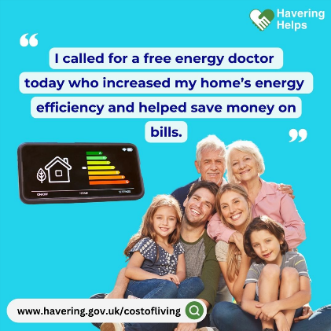 | Keep costs down by saving on energy bills.  Book your free Energy Doctor service to improve your home’s energy efficiency.  For more information: Financial help and advice | The London Borough Of Havering
Warm Spaces |  | Struggling to heat your home?  Save money on energy bills by using a free warm space near you.  Find out more: Financial help and advice | The London Borough Of Havering
Benefits Calculator |  | Financial worries?  Find out what support you're entitled to with a Benefits Calculator.  Find out more: Financial help and advice | The London Borough Of Havering

