Newsletter – Havering’s Young People Drug & Alcohol Service
Winter 2023
Your service provider Change Grow Live Wize-Up for all young people substance related issues

Christmas is nearly here, and as the year is coming to an end we wanted to give professionals and parents an update on the prevelant drugs we’ve seen in Havering in the last few months, the support we offer and how to refer.
Nitrous Oxide 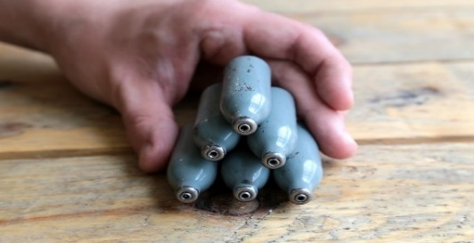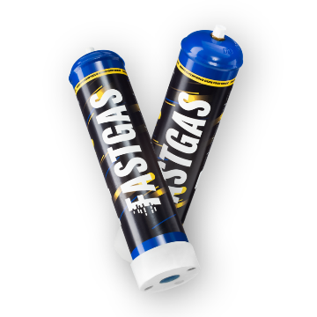
This Photo by Unknown Author is licensed under CC BY
As of 8th November 2023, Nitrous Oxide, or ‘laughing gas’, is classified as a Class C drug, marking a key change to how possessing this psychoactive substance is treated in law. Nitrous Oxide use is still very prevalent among young people, as the silver cannisters discarded in parks and public spaces highlights. However, the use of Smartwhip or Fast Gas is becoming even more prevalent. These much larger canisters contain significantly more nitrous oxide making the amount used harder to control and extremely dangerous. Nitrous Oxide is often referred to as either NO2, laughing gas, NOS or balloons… making it seem harmless, but it is anything but.
Risks with NOS include Vitamin B12 deficiency, suffocation, paralysis and even death. In a medical emergency with any substance always call 999 for urgent medical assistance.

Spice 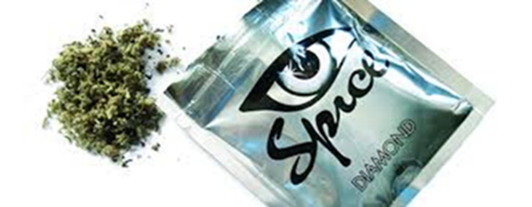 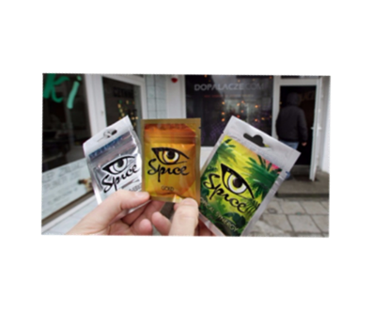

Synthetic cannabinoids or Spice – Black Mamba/ Devils Weed is a very dangerous drug that could previously be bought over counter if it said on the packet ‘not for human consumption’. In 2016 the Psychoactive Substances Act made the consumption of this drug illegal. However, this did not stop the illegal drugs market and it is now at a point where the drug is so potent that it can cause serious negative effects such as:
- Psychotic episodes and lasting negative effects on mental health
- An intense and trippy high
- Incoherency and unconsciousness
- Inability to walk or sit up
- Vomiting
- Small number of cases linked to death

Spice is popular in prisons as it is less detectable than cannabis and it is popular among homeless communities due to its ‘knock out’ effects. However, over the past few years we have seen this drug creep into the streets of Havering. So often young people do not want this drug, yet dealers sell spice in replace of cannabis as it is very difficult to tell the difference.
With the popularity of vaping THC now, young people are often vaping liquid spice, again, as it is nearly impossible to tell the difference. It is only once young people start smoking or vaping the substance, they can notice significant differences in the intensity of it’s effects.
Please note we have seen an increase in the rise of liquid spice being vaped in Havering in the past few weeks. If you suspect a young person has taken Spice, it is very important to dial 999 and ask for an ambulance if they are having a bad reaction.

Lean 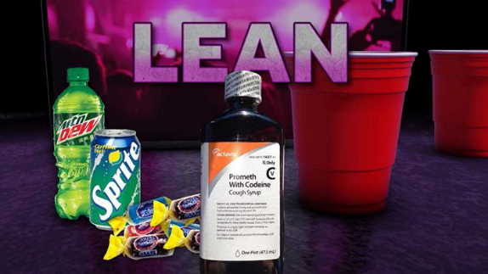 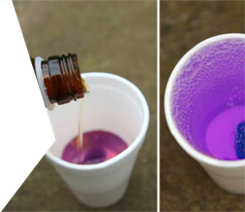

After returning from the summer holidays a key theme mentioned among young people at the college fresher’s fairs was the use of the drug lean. Lean is an American cough syrup containing Codeine and Promethazine often popularised in rap culture. It is not licensed on the NHS so young people make the substance themselves where the doses are incorrect and even more dangerous, or they buy the drug online. It is often mixed with a soft drink such as Sprite and sweets to enhance the taste. Lean is a depressant drug, and the risk of overdose is high especially when mixed with other substances such as alcohol. It takes just 6 days to get addicted to lean where a young person could experience similar but milder symptoms of heroin addiction.
It is very important if you know a young person using Lean daily to not encourage them to suddenly stop. If a young person was using Lean and we were worried about dependency, we would refer to the adult service for the young person to receive medical support and to be safely weaned off the substance. Please note this also applies if the young person was using Alcohol or Benzodiazepines dependently.

What support do Wize-Up provide?
Wize Up’s YP substance misuse service provides a free and confidential service for young people aged 10-18 offering:
- Brief intervention, a one-off education and awareness session, looking at harm reduction and consequences.
- Structured intervention, up to 12 weekly sessions aimed at young people who want to reduce or stop their substance misuse, developing a care plan and weekly goals.
- Hidden harm resilience work, up to 12 weekly sessions for children from age 5 who are affected by a family member’s drug or alcohol use.
- Small group workshops, tailored to suit individual needs.

Training
Wize Up provides Substance Misuse training for professionals. Our most popular workshop is the New and Prevalent Drugs education and awareness training, which is great to refresh your own knowledge or learn about drugs completely from scratch and to learn about the current trends in the borough.
This training can be delivered virtually or face to face. To discuss any specific training requirements or book a session for your team, please contact me today and we can develop sessions to suit your needs.

Parent Group
We’ve recently trialed our Parent Group and I’m very happy to offer the next dates for this 6-week program running from Thursday 11th January until Thursday 15th February 2024. Held at The Hub in Romford from 5.45pm – 6.45pm. This is a support group for parents who have children misusing substances, offering a safe place to open up, and learn more about substances. Please see parent group poster attached and contact details to book on.

After working as a resilience worker for Wize Up for over 3 years I am delighted to introduce the new team as I stepped into the team leader role earlier this year:
Becky Wood Team Leader
Hannah Douch Resilience worker/ Children and families hidden harm worker
Brogan Hammond Resilience worker based at the Youth Justice Service
Katie Adams School liaison/ Resilience worker

Contact Details:
Email: wizeuphavering@cgl.org.uk
Tel: 07909 097621
Refer Someone: https://www.changegrowlive.org/content/cgl-wize-up-havering/professionals-family-referral-form
We are open Monday to Friday 9.00am to 17.00pm and work throughout the Havering borough in schools, children’s centres, the Youth Justice Service as well as in the community.

For any information on services, harm reduction advice and referrals please contact me today!

Merry Christmas from the Wize Up Team!
Becky, Hannah, Brogan & Katie
